**3/17/2024**

Not applicable to jalr

Not added nop

Operational for add,addi

@00000000

00500293 Addi t5 t0 5

00300313 addi t6 t0 3

00002403

00100493

00940533

006283B3 add t7 t5 t6

00100493

00940533

00002403

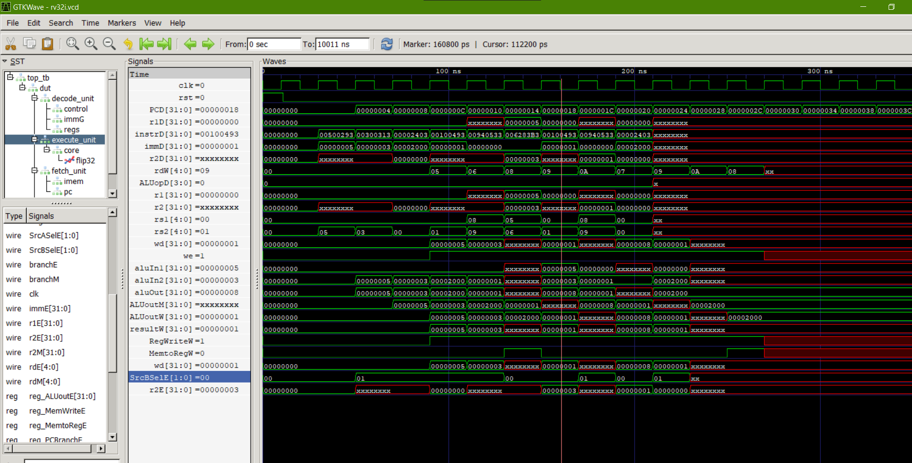

**19/3**

**Added nop**

@00000000

00500293

00300313

00000000

00000000

00000000

006283B3

00000000

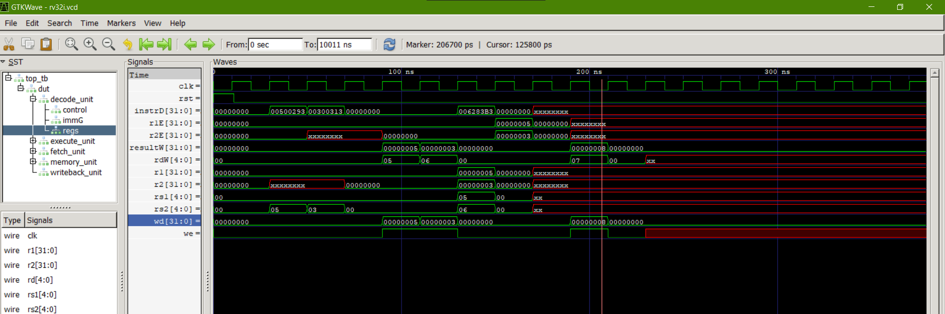

**19/3**

Load, store data path working

Data memory not working properly

Cannot handle hazards

@00000000

00500293 Addi t5 t0 5

00300313 addi t6 t0 3

00000000

00000000

00000000

006283B3 add t7 t5 t6

00000000

00000000

00000000

00701123 sh t7, 2(t0)

00000000

00202483 lw t9, 2(t0)

00000000

00000000

00000000

00000000

00000000

00000000

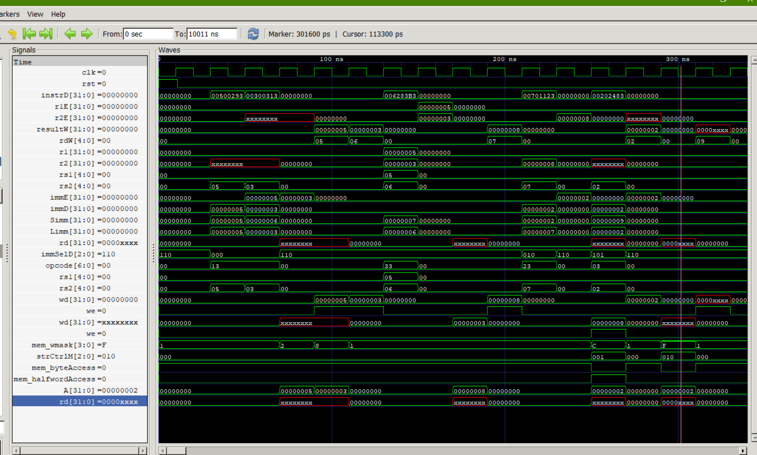

**23/3**

@00000000

00500293 Addi t5 t0 5

00300313 addi t6 t0 3

00000000

00000000

00000000

006283B3 add t7 t5 t6

00000000

00000000

00000000

00701123 sh t7, 2(t0)

00000000

00202483 lw t9, 2(t0)

00000000

00000000

00000000

00000000

00000000

00000000



**24/3**

@00000000

00500293 Addi t5 t0 5

00300313 addi t6 t0 3

00000000

00000000

00000000

006283B3 add t7 t5 t6

00000000

00000000

00000000

00701123 sh t7, 2(t0)

00702223 sw t7,4(0)

00202483 lw t9, 2(t0)

00402503 lw t10,4(t0)

00000000

00000000

00000000

00000000

00000000

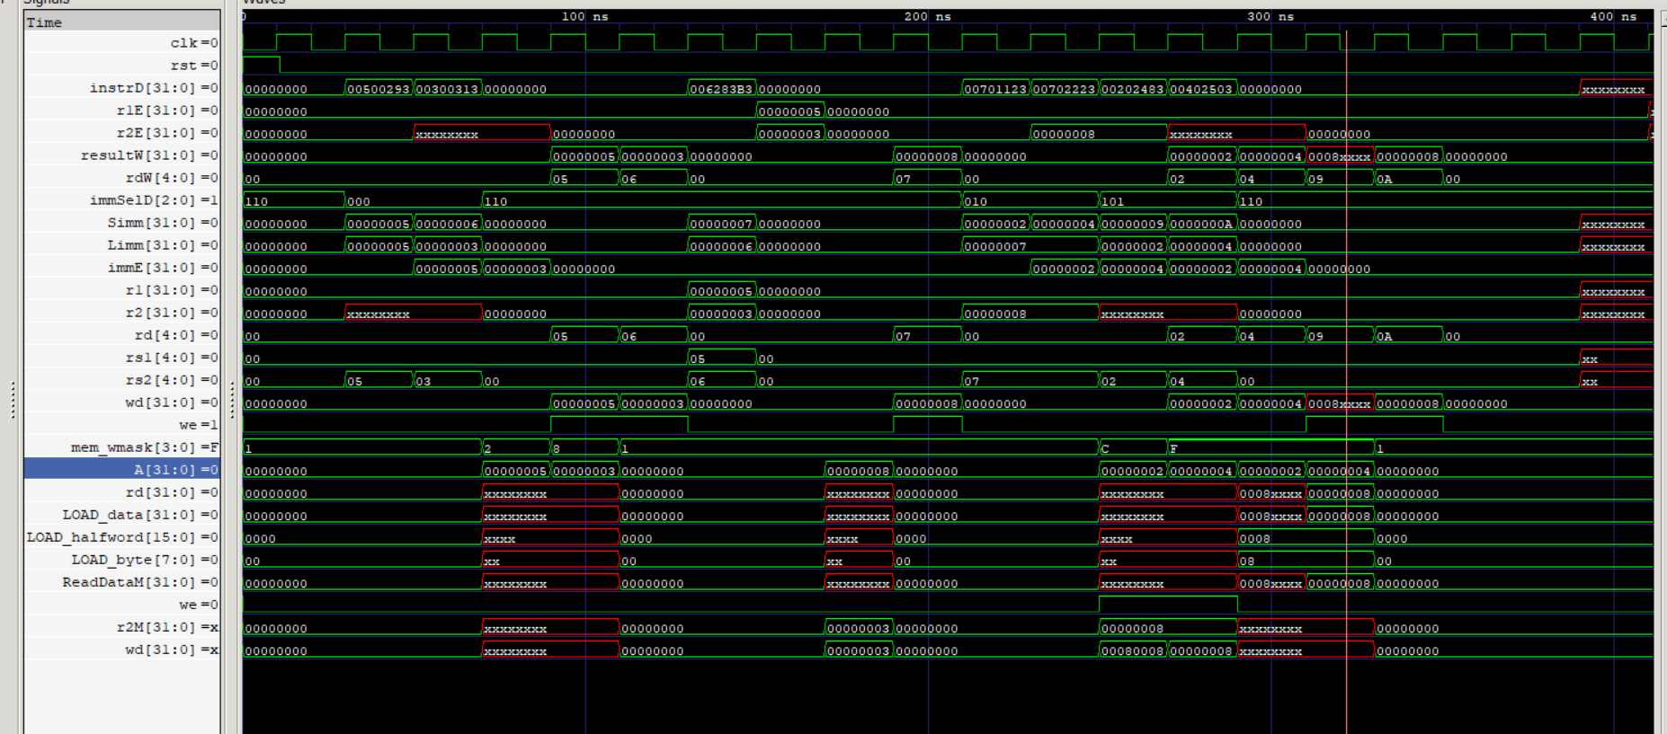

**Load store functional**

@00000000

00500293 Addi t5 t0 5

00300313 addi t6 t0 3

0000a5b7 lui t11 10

00000000

00000000

006283B3 add t7 t5 t6

00000000

00000000

00000000

00701123 sh t7, 2(t0)

00702223 sw t7,4(0)

00202483 lw t9, 2(t0)

00402503 lw t10,4(t0)

00000000

00000000

00000000

00000000

00000000

